UNIT-I

COURSE INTRODUCTION

#### Need for Value Education

All human beings aspire for a happy, fulfilling life. For a human being, there are two important questions pertaining to this:

* What is my aspiration? (What to do?)
* How to fulfil my aspiration? (How to do?)

The purpose of education is to facilitate the development of clarity on the aspiration and adequate competence to actualize it.

For this, it is essential to understand what a happy, fulfilling and successful life is – what is really valuable for human being; what is our purpose as a human being? Understanding human aspiration, or what is really valuable for human being, is the value domain. The subject which enables us to understand this domain is called ‘Value Education’ (VE). It enables us to understand our aspirations and visualise our goals for a fulfilling life and indicates the direction for their fulfillment. In relation to these issues, it also helps to remove our confusions and contradictions. In that sense, VE addresses the issues related to ‘what to do?’.

It is also necessary to learn the skills to actualise our aspirations. This is the skill domain. The subject which enables us to learn the skills is called ‘Skill Development’ (SD). It enables us to learn the science, technology, management and other skills for fulfilling our aspiration. In that sense, SD addresses the issues related to ‘how to do?’.

Values and skills go hand in hand. Both values and skills are required. There is an essential complementarity between the two. The priority is values, then skills; i.e. first understanding ‘what to do’ and then developing the skills for ‘how to do’. And of course, checking if this results into a fulfilling life!

The present education system has largely become skill-biased. For developing skills, the prime emphasis is on science and technology, without a base of values. Skills can only help to provide the means to achieve what is considered valuable. It is not within the scope of science and technology to provide a way to decide what really is valuable. The consequence of skill-biased education is clearly visible in the form of serious crises at the individual, societal and environmental level. Thus, there is a strong need to rectify this situation. Value education is a crucial missing link in the present education system.

But more importantly, the prime need of value education is to understand human aspirations, to discover what is truly valuable in life; and work out the program for its fulfillment.

#### Guidelines for Value Education

For any input to qualify for Value Education, the following guidelines for the content of the course are important:

*Universal:* It has to be universally applicable to all human beings for all time and all places. This implies that values should not change according to sect, creed, nationality, gender, etc.

*Rational:* It has to appeal to reasoning; and not be based on dogmas or blind beliefs. It has to be open to address the related questions. It cannot be a set of sermons or do’s and don’ts.

*Natural and Verifiable:* It has to be 'naturally acceptable' to the human being and there needs to be every provision in nature for its fulfillment. It needs to be experientially verifiable, and not based on dogmas, beliefs or assumptions. It is not merely an intellectual exercise or information transfer.

*All Encompassing:* It needs to cover all dimensions (thought, behaviour, work and understanding) and levels (individual, family, society and nature/existence) of human life.

*Leading to Harmony:* It ultimately needs to promote harmony within the individual, among human beings and with the entire nature.

#### Content of Value Education

**The value of an entity is its participation in the larger order of which it is a part.** The context is always the larger order. Value has to do with the participation of a unit in the larger order. E.g. a piece of chalk is a unit. The classroom is the larger order for this unit. The value of chalk is that it can be used to write on the blackboard for the desired functioning of the classroom.

The value or role of a human being is its participation in the larger order. E.g. my role in living with the other human being is to ensure the feeling of respect in the relationship. Interestingly, I feel happy in fulfilling my role; and it is fulfilling for the other as well!

This value is worth understanding, worth thinking about, worth living. The value of human being is to ensure mutual fulfilment in the larger order1, i.e. in the entire nature/existence, but starting from within themselves, then extending in their family and in the society.

Hence, to understand human values, we need to study the human reality along with all that is there in the entire nature/existence which constitutes the larger order. We need to explore and understand things as they are; so that we are able to recognise and fulfil our participation with them.

That means the content or scope of study has to be all encompassing, i.e.

* It has to cover all dimensions of human being – thought, behaviour, work and realisation.
* It has to cover all levels of human living – individual, family, society, nature and existence.

Accordingly, the content of Value Education has to be to understand human being, human aspirations, happiness; understand the goal of human life comprehensively; understand the other entities in nature, the innate inter-connectedness, the harmony in the nature/existence and finally the role of human being in this nature/existence.

Continuous Happiness and Prosperity as Basic Human Aspirations

Whatever we think, whatever we do is with some end state in mind. That end state is our basic aspiration.

When you ask yourself:

* Do I want to be happy?
* Do I want to be prosperous?
* Do I want the continuity of happiness and prosperity?

The answers are in affirmative yes. We have a natural acceptance for continuity of happiness and prosperity. These are our basic aspirations.

Basic Requirements for Fulfilment of Human Aspirations

When we try to find out if we have fulfilled our basic aspiration, it is not always so affirmative. There is quite a gap between our basic aspiration and our state of being.

When we reflect on all the effort we are making, we can easily see that we are generally working for accumulation of physical facility!

The basic problem is that we have assumed that ‘happiness and prosperity will automatically come when we have enough physical facility’.

This is something we need to explore in our own life. Where are we putting in our effort?

If continuity of happiness and prosperity is not achieved by just accumulating physical facility then what else is essential to do? Let’s try to find out by asking this question to ourselves:

Is the unhappiness in my family

* + More due to lack of physical facility or
  + More due to lack of fulfilment in relationship?

When you explore into it, you will find that the major reason for the unhappiness in the family is the lack of fulfilment in relationship and not just the lack of physical facility.

Now to look at the investment of your effort, find out:

* + How much time and effort you are investing for physical facility, and
  + How much time and effort you are investing for fulfilment in relationship?

Generally, most of the time and effort is being invested for physical facility, assuming that everything is going to be fine when there is enough physical facility, and there will be no unhappiness in the family.

The problems are more due to lack of fulfilment in relationship, and we are investing major part of our time and effort for physical facility.

With this discussion, the conclusion that we want to draw out of this is a very simple one:

###### For human being physical facility is necessary, but relationship is also necessary.

In fact, by seeing this, we can understand the difference between animals and human beings. Physical facility is necessary for animals as well as for human beings. For animals, it is necessary as well as adequate. But when it comes to human beings, that is not the case – physical facility is a necessity, but physical facility alone is not going to suffice for the fulfilment of human being.

When a human being has lack of physical facility, (s)he becomes uncomfortable and unhappy. Once (s)he gets the physical facility, (s)he forgets about it and starts thinking about many other things.

So, we can conclude that physical facility is necessary for animals; it is necessary for human beings also. However:

* For animals, physical facility is necessary as well as adequate.
* For human beings, physical facility is necessary, but physical facility alone is not adequate.

While we do have a natural acceptance to live in relationship, are we actually able to ensure living in relationship? Have we understood this or just assumed it? To explore this further, find out if:

* + 1. You want to live in relationship (harmony) with others or
    2. You want to live in opposition with others or
    3. You believe, living has to be necessarily in opposition with others, i.e. there is 'struggle for survival', ‘survival of the fittest’ and if you feel happy living this way?

A little introspection will show that out of these three, what is naturally acceptable is the first one. You certainly do not want to live in opposition with others. But you may be conditioned to think in a manner as mentioned in the third option. If we adopt the third option, it has significant negative implications in our life, in the family and in the society. We can see this all around today.

In relationship, what is generally happening today is something like this:

*Every time when there is fight, we want to resolve it. We start the next day with the thought that we don’t want to fight today; but a fight takes place again (sometimes by the end of the same day).*

Does this happen with you, with your brother, sister, father, mother, spouse, children, with your friends, co-workers, etc.? Getting irritated, angry, not speaking for days, dragging each other to court, divorces, etc. are indicators of the situation in relationship.

For ensuring fulfilment in relationship, it is necessary to have right understanding about relationship.

From the preceding discussion, it may be concluded that **for fulfilment of human being– physical facility, relationship and right understanding – all three are necessary.**

We can see that physical facility, relationship and right understanding are three distinct realities. All three are required for fulfilment of human being. One cannot be substituted for the other.

If we investigate into the priority among these, we can see that right understanding is the first priority, fulfilment in relationship with human being is the second priority and ensuring physical facility with rest of nature is the third priority.

Right Understanding, Relationship and Physical Facility

Human being wants to live with continuous happiness and prosperity and this is possible by ensuring right understanding, fulfilment in relationship and physical facility in the correct priority. This is living with ‘human consciousness’.

On the other hand, if one is living for physical facility alone, and not ensuring right understanding and right feeling in relationship, s(he) feels unhappy and makes others unhappy too. This is one outcome.

The other outcome is that if the right understanding is missing, one is not able to identify the need for physical facility. Now, if we are not able to identify our need for physical facility then regardless of how much physical facility we accumulate, we never feel that we have enough. We keep wanting more. This feeling of not having enough is the feeling of deprivation. As a result, one is deprived, exploiting and depriving others.

While physical facility alone may suffice for animals, it is not adequate for human being to be fulfilled. Under this condition, one is living with ‘animal consciousness’.

There are generally two kinds of people today:

1. Those lacking physical facility, unhappy and deprived
2. Those having physical facility, and yet unhappy and deprived Try to find out where you are – at 1 or at 2?

Whereas we really want to be is in the following state, i.e.

1. Having physical facility, happy and prosperous.

It is easy to see that we naturally want to be in the state 3, of having more than required physical facility, happy and prosperous. However, today we seem to be at 1 or 2 and our effort is generally for 2. You can see that what is called development today largely takes us from ‘1’ to ‘2’.

Now, if we are able to ensure all three, i.e. right understanding, relationship and physical facility, in that order of priority, let us see the outcome (refer to fig. 3-5).

* Through right feeling in relationship, based on right understanding, we can ensure mutual happiness – happiness for ourselves as well as happiness for others.
* With right understanding, we can identify the need for physical facility. We can also learn how to produce using a mutually enriching production process. Once we are able to ensure the availability of more than required physical facility, we have a feeling of prosperity; isn’t it?

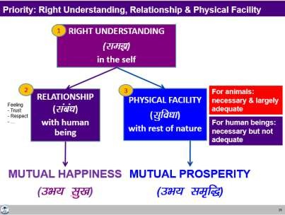

#### Development of Human Consciousness

We can clearly envisage holistic development as the transformation of consciousness –to human consciousness. Of course, it will necessitate working on all three – right understanding, fulfilment in relationship as well as physical facility; and in that order of priority.

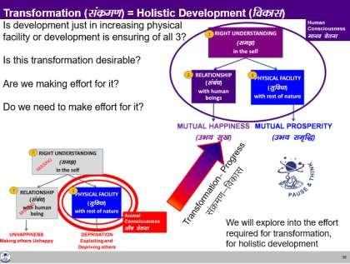

#### Role of Education-Sanskar

(Enabling the Transformation to Human Consciousness)

The role of education is essentially to facilitate holistic development, i.e. the individual transformation to human consciousness as well as the societal transformation to a humane society.

For this, the education-sanskar has to ensure:

* 1. Right understanding in every child,
  2. The capacity to live in relationship with other human beings, and
  3. The capacity to identify the need for physical facility, the skills and practice for sustainable production of more than what is required, leading to the feeling of prosperity.

###### Education is developing the right understanding (holistic perspective).

**Sanskar is the commitment, preparation and practice of living with right understanding. The preparation includes learning appropriate skills and technology.**

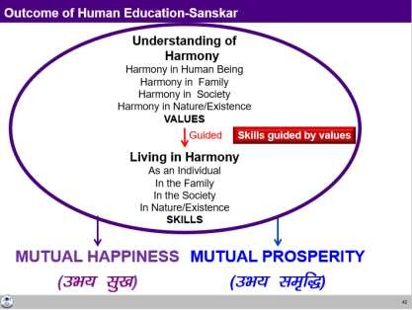

#### Key Takeaways

The prime need of value education is to understand human aspirations, to discover what is truly valuable (human value) in life. Value of any entity is its participation in the larger order of which it is a part. The value of human being is its participation towards mutual fulfillment (harmony) starting from within themselves, then extending in their family, in the society and in nature. The content of value education has to be universal, rational, natural, verifiable and leading to harmony. The process of value education has to be a process of self-exploration, rather than being prescriptive.

The basic aspiration of a human being is continuity of happiness and prosperity. To fulfil this, three things are required in order of priority: right understanding, relationship and physical facility, and one cannot be substituted for the other.

Human consciousness is living with continuous happiness and prosperity by ensuring right understanding, fulfilment in relationship and physical facility in the correct priority. Holistic development is the transformation from animal consciousness to human consciousness. Education- sanskar has the most significant role to play in this transformation.

## Process of Value Education – Self-exploration

Human Values can be understood by an appropriate process of self-discovery, because they are potentially there in each and every human being. There is already a natural acceptance for values in a human being. It is only that we have to discover them or become aware of them. Thus, the process for Value Education has to be that of self-exploration, and not of giving sermons or telling dos & don'ts. Whatever is found as truth or reality may be stated as a proposal and every student is to be encouraged to verify it on his/her own right.

You can check if you want to be able to decide on your own right or you want somebody else to decide for you? This somebody may be a group of people; it may be the society or the education system, etc. If you are not able to decide on your own right then:

* Someone else is programming you (deciding what is valuable and what is not valuable for you)
* Unconsciously you keep accepting those things as values
* You get busy with how to implement them, how to realise them and materialise them

This process of Self-exploration has to be in the form of a dialogue – a dialogue between the teacher and student to begin with; and finally, within the student – between ‘what I am’ and ‘what I really want to be’, which is the innate natural acceptance.

#### What is Self-exploration?

It is a process of seeing the reality on our own right, by our own investigation, observation and analysis. Through this process, we are trying to understand the reality that exists and our participation with it; this participation is what we are calling values.

The first step is to verify the given proposal on your own right, by referring it to your ‘natural acceptance’. If the proposal is naturally acceptable to you, it is right for you. If it is not naturally acceptable to you, it is not right for you.

Further, self-exploration is a process of dialogue. To begin with, it is initiated as a dialogue between us and you. This course systematically presents a series of proposals for your exploration. As you explore, you try to verify the proposals and start asking these questions to yourself. Then, it turns into a dialogue within your own Self.

#### The Dialogue Within

It is a dialogue between “what I am” and “what is naturally acceptable to me”.

“What I am” has to do with my desires, my thoughts, my expectations; all that is going on in my imagination. It includes the way I feel, the way I think, how I make decisions, what I expect from others and all that. It is my current competence on the basis of which I live.

“What is naturally acceptable to me” is what I really want to be, that is my natural acceptance. It is my intention. It is a basic reference which is a part and parcel of every human being. We may or may not be referring to it at present, but it is always there.

When we are in harmony within, we are in state of happiness. When we are in a state of contradiction within, we are in the state of unhappiness.

Therefore:

###### Happiness is to be in a state of harmony.

**Unhappiness is to be forced to be in a state of contradiction.**

We don't want to be in contradiction, so whenever there is contradiction, we want to run away from it; but if we cannot run away, and if we are forced to be in that state, we call it unhappiness.

It is possible for each one of us to do this self-exploration. The dialogue within constitutes the major part of it. Through this, we:

1. Discover our natural acceptance
2. Become aware of “what I am”
3. Can make effort to ensure harmony and happiness within by ensuring that “what I am” is in line with my natural acceptance.

#### The Content for Self-exploration

The content for self-exploration has two sub-parts:

1. Desire: What is our basic aspiration?
2. Program: What is the way to fulfil this basic aspiration?

If we are able to get the answer to these two things, practically all our questions are answered

#### The Process of Self-exploration

Whatever is stated here is a proposal; do not assume it to be true or false, right or wrong. Verify it – verify it on your own right, on the basis of your natural acceptance. This is the first part of the process.

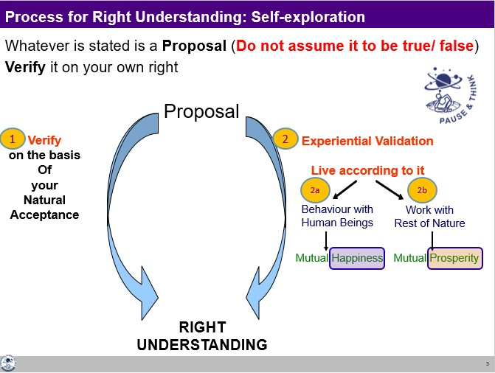

The second part of self-exploration is experiential validation. It means trying to live according to the proposal. In living, there are two parts – one is the behaviour with other human beings and the second is work with rest of nature. When we are behaving with human being on the basis of this proposal, we want to verify whether it leads to mutual happiness or not. If it leads to mutual happiness, it is a right proposal; if it does not lead to mutual happiness, it is not a right proposal. Similarly, when we are working with rest of nature on the basis of this proposal, we want to verify whether it leads to mutual prosperity or not. If it leads to mutual prosperity, it is a right proposal; if it does not lead to mutual prosperity, it is not a right proposal.

#### Understanding Natural Acceptance – the basis for Right Understanding

(Distinguishing between acceptance and natural acceptance)

Natural acceptance has to do with something fundamental, something related to our purpose, something related to our basic desires. When we ask a question related to these, we get a definite answer from our natural acceptance. For example,

* Is happiness naturally acceptable or is unhappiness naturally acceptable?
* Is it naturally acceptable to live in relationship or in opposition?
* What is naturally acceptable – to nurture your Body or to exploit it?

For all these questions, we get a definite answer when we refer to our natural acceptance.

On the other hand, we have an acceptance for our likes and dislikes, assumptions, pre-conditionings, beliefs, world-view, perspective, etc. but these may or may not be naturally acceptable to us.

Of course, all acceptances are not wrong. Passing them through our natural acceptance will validate them and contribute to our self-confidence.

Some of the characteristics of natural acceptance are:

* *It does not change with time*
* *It does not change with place*
* *It does not change with the individual*
* *It is uncorrupted by likes and dislikes or assumptions or beliefs*
* *It is innate, a part and parcel of our being; we don’t need to create it*
* *It is definite*

As we refer to our natural acceptance, we become self-referential.

To conclude, the complete process of self-exploration yields right understanding as the tangible outcome.

Right understanding obtained through self-exploration can be recognised as follows:

1. It is assuring
2. It is satisfying
3. It is universal
   1. Time: It holds good for all time – past, present and future
   2. Space: It is the same at all places or locations
   3. Individual: It is the same for every human being

In case the outcome of self-exploration does not fulfil any of the above three criteria, it means that it is not the right understanding. It could be a pre-conditioning or we have made a mistake in looking into our natural acceptance and so, we need to continue exploring.

Self-exploration ultimately results in right understanding of the entire existence, i.e. “realisation of co- existence”, “understanding of harmony” and “contemplation of relationship”.

#### Key Takeaways

Self-exploration is a process of seeing the reality on our own right, by our own investigation, observation and analysis. It is a process of dialogue between “what I am” and “what is naturally acceptable to me”. It includes verifying the proposals on the basis of natural acceptance (which is not the same as acceptance) and validating experientially in living.

## Exploring the Meaning of Happiness and Prosperity

As stated earlier, the proposal for happiness is:

“The state or situation, in which I live, if there is harmony / synergy in it, it is Naturally Acceptable to me to be in that state / situation”.

“To be in a state / situation which is Naturally Acceptable is Happiness”.

i.e. “To be in a state of Harmony / Synergy is Happiness”.

###### i.e. Happiness = Harmony.

Some exploration will show that when we are in a state of harmony within, we feel happy because that state is naturally acceptable to us. When we are in a situation with the outside world in which there is harmony, we feel happy as the feeling of being in that situation is naturally acceptable to us. This state or situation of being in line with natural acceptance is happiness. Similarly,

“The state or situation, in which I live, if there is disharmony / contradiction in it, it is not Naturally Acceptable to me to be in that state / situation”.

“To be forced to be in a state / situation which is not Naturally Acceptable is Unhappiness”.

i.e. “To be forced to be in a state of Disharmony / Contradiction is Unhappiness”.

**i.e. Unhappiness = Disharmony.**

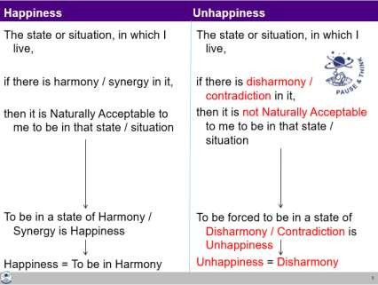

Is Happiness the same as Excitement?

The question is whether the feeling that we get is happiness or something else.

* + What we get from the favourable sensation = happiness?
  + Is the favourable feeling we get from the other = happiness?

What we get in both cases is a sort of momentary happiness. This is what is called as excitement. There is confusion between excitement and happiness (a harmonious state within). Excitement is short lived, not sustainable, while a harmonious state within is something which can be continuous and sustainable.

#### Exploring the Meaning of Prosperity

###### Prosperity is the feeling of having more than required physical facility.

There are two basic requirements:

1. Right assessment of the need for physical facility, along with its required quantity.
2. Ensuring the availability/production of more than required physical facility.

We can have a feeling of prosperity only if we are able to do the right assessment of our physical needs. The right assessment of physical needs, along with their required quantity, will come through right understanding. Without that right assessment, the feeling of prosperity cannot be assured, regardless of the availability or accumulation of physical facility that we may have been able to do.

Just assessing the need is not enough. We need to ensure the availability or production of more than the required quantity. This requires skills, technology and production. With both of these, right assessment and availability, we have more than required physical facility. Over and above that, it is a matter of feeling that we have more than enough.

When you have a feeling of prosperity, you will naturally think of nurturing and enriching others. On the other hand, if we feel deprived then we think of exploiting and depriving others.

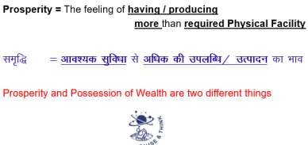

#### Prevailing Notions of Prosperity

By and large, there is confusion between accumulation of physical facility and the feeling of prosperity. It is generally assumed that the richer you are, the more prosperous you are, i.e. the more you have accumulated, the more prosperous you are. With this sort of assumption, we pursue prosperity with an obsession for profit, for accumulation. That is happening all around. The major focus in the society today is on accumulation of physical facility. In particular, there is a major focus on accumulating money.

Today, most of the wealth (money) in the world is owned by a very tiny percentage of people. Many such people are seen exploiting others, and exploiting the Earth, in an effort to accumulate even more. Without clarity about how much is required, the effort is for an unlimited quantity of physical facility, and by almost any means. First the efforts may be by legal means, and then slip to even illegal means. This is all because the quantity required is undefined and there is a feeling of deprivation!

#### Program for Continuity of Happiness

The expanse of our living is at the following four levels:

1. As an Individual human being
2. As a member of a family
3. As a member of society
4. As a unit in nature/existence

We are living with all this expanse of our being, at these four levels; of course, we may or may not be aware of it.

Therefore, the programme for ensuring the continuity of happiness is:

To understand the harmony at all levels of being:

and 1. At the level of the individual human being

To live in harmony 2. At the level of family

* 1. At the level of society and
  2. At the level of nature/existence

#### Key Takeaways

Happiness is to be in a state of harmony. The expanse of our living is at four levels (individual human being, family, society and nature/existence), and thus the program for continuity of happiness is to be in harmony at all these levels. Prosperity is the feeling of having more than required physical facility.

.

UNIT-II

# Understanding the Human Being

## (As Co-existence of Self and Body)

We are human beings; and we need to first understand ourselves.

So, what is a human being? The proposal is that human being is co-existence of the Self and the Body. Self is what we term as ‘I’ and Body is what we see with our eyes.

To understand the two realities, we can start by looking at the needs, activities and response of the Self and the Body.

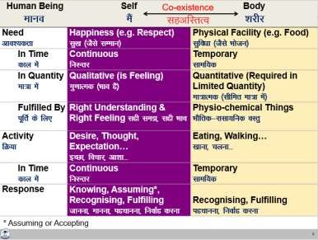

#### The Needs of the Self and the Body

The need of the Self is happiness (e.g. feeling of respect leading to happiness) while the need of the Body is physical facility (e.g. food). All the needs related to the Self are continuous in time while all the needs related to the Body are required for a limited time. This is one way we can differentiate between the need of the Self and the need of the Body.

The other way to see the difference between the two is in terms of quantity and quality. The need for food is quantitative in nature. We can identify the quantity of the food needed to nurture our body. Same is the case with the need of clothes, shelter, etc. On the other hand, the feeling of respect, trust, etc. is not quantitative. We don’t say, ‘today I got half kg of respect’ or ‘two metres of trust’. These feelings are qualitative in nature.

Now, let us see how these two different types of needs are fulfilled. The need for food is fulfilled by something physical. But when it comes to the need for respect, it is fulfilled by the feeling of respect. All the needs related to the Body are fulfilled by some physio-chemical things. All the needs related to the Self are in terms of feeling, and they are fulfilled by right understanding and right feeling.

#### The Activities of the Self and the Body

The Self has the activity of desire, thought and expectation which are continuous. On the other hand, any activity of the Body, like eating, walking, etc. is temporary in time.

#### The Response of the Self and the Body

The response of the Body is based on recognizing and fulfilling whereas the response of the Self is based on knowing, assuming, recognizing and fulfilling. The recognition and fulfilment of the Body is definite, while that of Self is determined by the activity of assuming. As assumption changes, the recognition and fulfilment by the Self also changes. The conduct of the human being basically depends upon the response of the Self, as all decisions are made by the Self. Only with the assumptions set right,

i.e. assuming based on knowing (which is definite), can recognising and fulfilling be set right; and only then, the conduct can become definite.

All the problems of a human being are due to assumptions without knowing, and the solution lies in ensuring the activity of knowing. And this is possible only through education-sanskar.

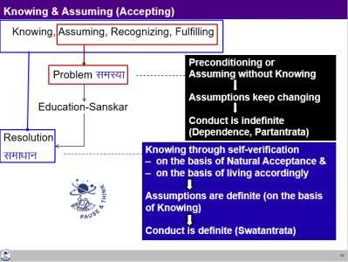

#### The Self as the Consciousness Entity, the Body as the Material Entity

The Self and the Body are two different types of reality. The Self is the domain of consciousness, which is characterised by the activity of knowing, assuming, recognising and fulfilling. The Body is the domain of material and it only has the activity of recognising and fulfilling.

Happiness is the need of the consciousness and it is fulfilled by right understanding and right feeling, which are activities of the consciousness itself. The Body is a material unit, its needs are material in nature and they are fulfilled by physio-chemical things.

To understand the human being, both the domain of consciousness as well as the domain of material needs to be understood. For human being to be fulfilled, both domains need to be fulfilled separately.

#### Key Takeaways

Human being is co-existence of the Self (Consciousness) and the Body (Material). This can be seen on the basis of exploring into the need, fulfilment of need, activity and response of the Self and the Body. In particular, the response of the body is definite while the response of the self depends on assuming. With assuming based on knowing, the conduct of a human being gets definite, otherwise it is indefinite.

#### Gross Misunderstanding – Assuming Human Being to be only the Body

The gross misunderstanding is assuming the human being to be the Body; and therefore, trying to fulfil all the needs through physical facility.

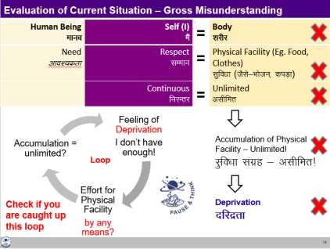

It is needless to say that due to over-use of physical facility, there are widespread repercussions at every level of human existence. On the one hand, there is exploitation of natural resources for more and more physical facility. On the other hand, human beings are exploited in the process and also, they are made to compete for the limited physical facility.

#### The Way Ahead

The only way to come out of this misunderstanding is to understand the human being as it is. The Self has to be understood as a conscious entity and Body as a material entity. Their needs are different, activities are different, response is different and basically, they are two different entities co-existing as a human being.

#### Key Takeaways

The needs of the Self and the Body are of two different types, so they have to be fulfilled separately. A gross misunderstanding is to assume the two to be the same, and this leads to the feeling of deprivation and exploitation.

## Understanding Harmony in the Self

Now we will explore into the activities of the Self and see how harmony can be ensured among all the activities of the Self, resulting into a state of continuous happiness.

#### Activities of the Self

The activities of the Self can be seen in terms of desire, thought and expectation.

Desire is the name given to the activity of imaging. You are making an image in the Self. Desire is in the form of an image which you have created within. Thought is the power for the activity of analysing based on comparing various possibilities to fulfil your desire. Expectation is the power for the activity of selecting based on tasting.

#### Activities of the Self are Continuous

These powers of desire, thought and expectation are inexhaustible, and the activities are continuous. The activities of imaging, analyzing-comparing and selecting-tasting are always going on, whether we are aware of them or not.

#### These Activities Together Constitute Imagination

These activities are together called imagination. We may not immediately be able to observe our desire, thought and expectation distinctly, but it may be easier to see that something is going on within. One imagination or the other is going on in us all the time.

Happiness and unhappiness depend on the state of imagination. If your imagination is in harmony with your natural acceptance, you are in a state of happiness. When it is in contradiction with your natural acceptance, you are in a state of unhappiness.

Imagination is expressed to the world outside, in terms of behaviour with human being and work with the rest of nature.

We have also referred to imagination as “what I am” and the natural acceptance as “what I really want to be”.

#### State of Imagination

Once you start looking at your imagination, you will be able to find out the state of your imagination. Your imagination could be well organised, in harmony or it could be a random mixture of harmony and contradiction.

#### Possible Sources of Imagination

There are three possible sources of motivation for imagination: 1. Preconditioning, 2. Sensation and 3. Natural Acceptance

A dominant source of imagination is preconditioning. Preconditioning means the beliefs, notions, norms, ideas, views, dictums, goals, etc. prevailing in the family, in the society which we have assumed without knowing. They may influence our imagination.

Another major source of our desire, our imagination is the sensation. Sensation is the information we get from the Body through the five sense organs – of sound, touch, sight, taste and smell.

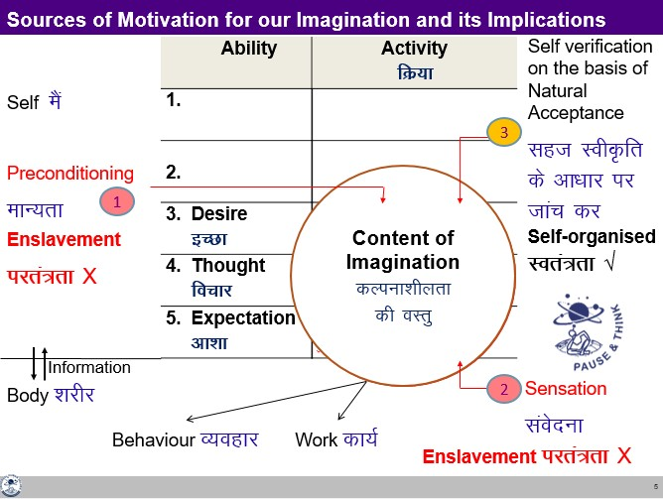

The third source of imagination is our natural acceptance. It can also be referred to as the inner voice or conscience. Self-verification on the basis of our natural acceptance can be the third possible source. It may or may not be the predominant source of motivation currently, but it can be the real source for deciding our desire, our imagination.

#### Consequences of Imagination from the three Sources

– Self-organisation or Enslavement?

If your imagination is motivated by preconditioning or sensation, you may or may not be in harmony with the natural acceptance. Therefore, you may be in a state of happiness within or unhappiness within. Your happiness is dependent or enslaved by your preconditioning and sensation.

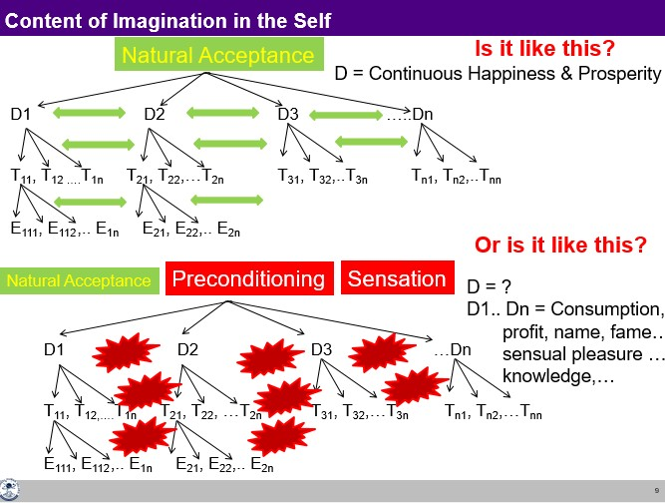

And then there is a large possibility that there is contradiction in your desires, leading to contradiction in your thoughts and then expectations. In such a state of contradiction within, your imagination is enough to keep you unhappy all the time.

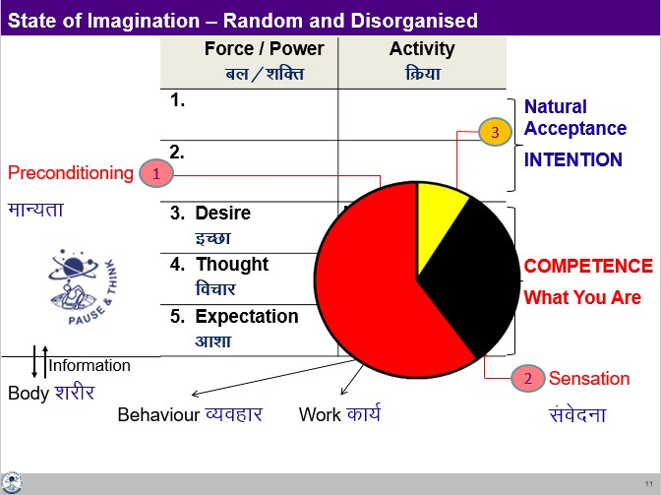

There is a possibility that a large share of your imagination is enslaved by preconditionings and sensations, while a very small share is guided by your natural acceptance. One thing to note here is that sensation is not an enslavement in itself. Through sensation only, the Self is able to take proper care of the Body. But problem arises when you try to associate happiness with favourable sensations. Similarly, there could be some preconditioning which may also be right. But unless you verify it, and validate in your living, it is just like an enslavement. And this leads to unhappiness.

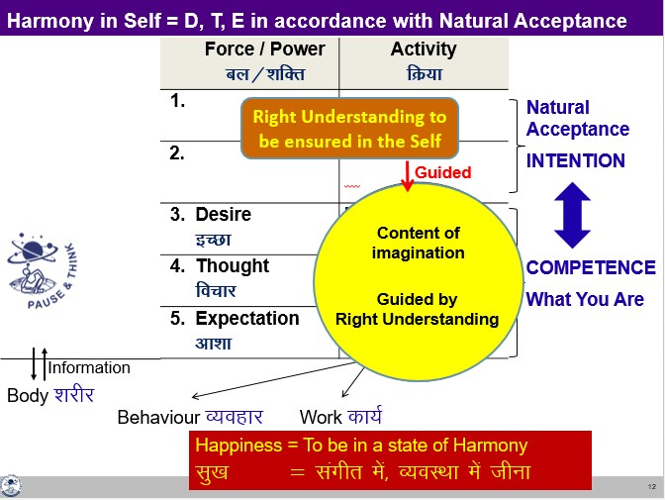

If your imagination is guided by your natural acceptance, you are sure to be in harmony and happiness within. You are self-organized.

#### The Way Ahead

* Ensuring Harmony in the Self by way of Self-exploration

To achieve this harmony in the Self, we need to start self-exploration. In the process, we need to:

* + Know our natural acceptance
  + Be aware of our imagination
  + Find out the source of imagination
  + Work out a way to sort out our imagination till it is fully in line with our natural acceptance When the imagination is in harmony with the natural acceptance, there is harmony in the Self. This harmony is happiness.

#### Key Takeaways

The activities of desire, thought and expectation are together called imagination. Imagination is continuously going on in the Self. The sources of imagination can be sensation, pre-conditioning or natural acceptance. There is harmony in the Self when the imagination is in line with one’s natural acceptance. Harmony in the Self is in continuity when all the activities of the Self are awakened.

## Understanding Harmony of the Self with the Body

In this lecture, we will discuss the harmony of the Self with the Body, and try to understand self- regulation and health.

#### The Body as a Self-organised System

The Body is a wonderful self-organised system. It has so many parts. Each part co-exists in harmony with every other part. The eyes are well connected to the brain; the mouth, the stomach and the whole digestive system is synchronized and so it is for every organ, every cell of the Body – and you have to do nothing to make these connections or to synchronize the various parts or to deal with every cell.

#### Harmony of the Self with the Body: Self-regulation and Health

As we discussed in lecture 9, the Body is an instrument of the Self. The responsibility of the Self towards the Body is in terms of nurturing, protecting and rightly utilizing the Body. Nurturing the Body is by providing appropriate air, water, food, sunlight, etc. Protection is to ensure the continuity of the body which includes safeguarding from unfavorable conditions. Right utilization would mean using the Body for the purpose of the Self. This feeling of responsibility towards the Body is called as the feeling of **self-regulation**, and a natural outcome of it is **health**.

Feeling of self-regulation = the feeling of responsibility in the self towards the Body – for nurturing, protection and right utilization of the Body.

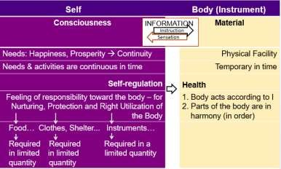

Indicators of a healthy body:

* + The Body is healthy if it is able to perform as per the instructions of the Self.
  + Different parts of the Body are in harmony amongst each other, they are in order.

The feeling of self-regulation in the Self is primary. Health in the Body is a natural consequence.

When the Self has the feeling of self-regulation and there is health in the Body, there is harmony of the Self with the Body.

#### Appraisal of the Current Status

Over the last 100 years or so, there have been significant improvements in terms of longer life-spans, in dealing with communicable diseases and trauma, but yet, ensuring health remains a question mark1. The problem is in the wrong assumptions, one of which is that human being is the Body. With this assumption, happiness is sought through favorable sensation through the Body. Further, the assumption that we will get happiness from sensation through the consumption of physical facility has led to a high demand for it. Most of the present-day disorders are psycho-somatic in nature. ‘Psycho’ has to do with the Self and ‘Somatic’ has to do with the Body. Disharmony in the Self causes disharmony in the Body causing psycho-somatic problems. These effects are very prominent when the individual is living with the assumption “I am the Body”.

#### The Way Ahead

There is a need to understand human being as it is (as co-existence of Self and Body). The significant part is having the feeling of self-regulation in the Self. This can happen only when the Self is in harmony, i.e. there is right understanding and right feeling in the Self. With a feeling of self-regulation, the Self will naturally nurture, protect and rightly utilize the Body, resulting in health of the Body.

#### Key Takeaways

The Body is an instrument of the Self. Harmony of the Self with the Body is ensured when Self has the feeling of self-regulation and there is health in the Body.

#### Programme for Self-regulation and Health

As we discussed earlier, feeling of self-regulation is the feeling of responsibility in the Self for nurturing, protection and right utilization of the Body. We can now detail it further:

#### Nurturing the Body

Nurturing means providing the necessary inputs to the Body. The right inputs nurture the Body, without disturbing its harmony.

The programme for nurturing and maintaining health of the Body includes the following: 1a. Intake 1b. Routine

2a. Physical Labour 2b. Exercise

3a. Balancing internal and 3b. Balancing breathing of body external organs of body

4a. Medicine 4b. Treatment

**1a.** The first part is the intake, all that the Body takes in. It includes the air it breathes, the water it drinks, the sunlight it absorbs, the food given to it and so on.

**1b.** A regular routine is required in order to keep the Body healthy, like ensuring a proper programme for sleeping, waking up, cleaning the Body, eating, doing physical work, etc.

**2a.** The Body needs adequate movement to maintain health. Labour is the work on the rest of nature. Few hours of labour a day provides sufficient body movements to keep the Body in good health. It also ensures production of physical facility.

A lifestyle which includes appropriate intake, routine and labour, would be generally sufficient to keep the Body in good health. However, if we are unable to do that, or in spite of this effort, there is some

1 Please refer to latest health data available from sources like the World Health Organisation (https://[www.who.int/)](http://www.who.int/))

disharmony in the Body, there are some more aspects of the programme for self-regulation and health, below.

**2b.** If one is not able to labor, s(he) can do exercises for proper upkeep of the Body.

**3a.** There is a need for keeping the internal as well as the external organs in harmony by appropriate means like postures, movements etc.

**3b.** Breathing is a significant activity for the Body. Balancing the breathing of body is necessary, through appropriate breathing exercises.

For the most part, health of the Body can be maintained by these three (1a, 1b, 2a, 2b, 3a and 3b). Despite these, if there is some problem in the health of the Body then we take medicine and ultimately, we also take treatment when all this does not work.

**4a.** The Body is self-organised and naturally in harmony. It is able to recover itself from many disturbances. But if due to some reasons it runs into disharmony, medicine is helpful in taking care of lifestyle disorders, non-communicable illnesses as well as communicable diseases.

**4b.** In the event the Body is not in a state to recover itself back to a state of harmony, there is a need for treatment.

Protecting the Body

Providing a conducive physical environment includes clothing, shelter etc. is all a part of protection of the Body.

Right Utilisation of the Body

Right utilization of the Body would mean that it is used in the process of fulfilling human aspiration, which is basically the need of the Self. If one is using the Body in the process of fulfilling the needs of the Self, it is right utilization of the Body. It would include work with rest of nature to produce physical facility required for the Body.

#### Revisiting Prosperity in the Light of the Harmony between the Self and the Body

The need for the physical facility is essentially related to fulfillment of this feeling of responsibility towards the Body, i.e. we need physical facility for nurturing the Body (food…), for protecting the Body (clothes, shelter…) and for rightly utilizing the Body (instruments…) and that’s it. And if we can see this clearly, we can also see that the physical facility required to ensure each one of them is required in limited quantity. Hence, prosperity is very much possible.

As an exercise, one can list all the physical facilities required for these three purposes, and see whether they are limited. Next, one can assess the available facilities, and see if they are more than required. If not, then how much more will be required can be worked out. This will clearly give a vision for ensuring prosperity.

#### My Participation (Value) regarding Self and my Body

My participation (value) with my Body is:

* + Ensuring a feeling of self-regulation in the Self
  + Ensuring the nurturing, protection and right utilisation of the Body
  + Ensuring the production / availability of more than required physical facility for the above

By ensuring these three, the Body continues to be in harmony, it remains healthy. And one also has the feeling of prosperity.

#### Key Takeaways

When the Self has a feeling of self-regulation (the responsibility for nurturing, protection and right utilisation of the Body), and it is able to fulfil this responsibility, the Body is in harmony (good health). This feeling of self-regulation is instrumental in identifying the need for physical facility and ensuring prosperity.

UNIT-III

UNDERSTANDING HARMONY IN THE FAMILY AND SOCIETY

Every human being is born in a family and is part of a family. The family is the basic unit or building block of human organisation. It provides a base for appreciating, accepting, understanding and practicing to live in relationship and harmony (order).

#### Feeling of Relationship as the Basis for Harmony in the Family

The harmony in the family has primarily to do with the fulfilment of relationship between one human being and the other human being. In order to fulfil relationship, it is necessary to understand relationship.

#### Understanding Relationship

We will now explore into the four important aspects of relationship:

* 1. Relationship is – between one Self (I1) and another Self (I2)
  2. There are feelings in relationship – in one Self (I1) for the other Self (I2)
  3. These feelings can be recognised – they are definite
  4. The fulfilment of these feelings and their right evaluation lead to mutual happiness

1. Relationship is – between one Self (I1) and another Self (I2)

Relationship is already there. We do not have to construct or create relationship. All we need to do is to understand relationship and fulfil it.

Relationship is between one Self and the other Self. It is the Self which is recognizing the relationship, and not the Body. It is the Self which relates to the other, and not the Body.

1. There are feelings in relationship – in one Self (I1) for the other Self (I2)

The important issue in human relationship is that of the feelings. We can see that feelings are in the Self, not in the Body. It is the Self which has the feelings and which recognises the feelings. To understand relationship, one has to understand the Self and the naturally acceptable feelings in the Self.

1. These feelings can be recognised – they are definite

These feelings can be recognised, they are definite. There are nine feelings in relationship. These are the feelings which we can understand, which we can ensure within ourselves, which we can share with others and thus ensure mutual fulfilment in relationship. These are the feelings which are naturally acceptable to us in the relationship with the other human being.

Feelings (values) in relationship:

* 1. Trust (foundation value)
  2. Respect
  3. Affection
  4. Care
  5. Guidance
  6. Reverence
  7. Glory
  8. Gratitude
  9. Love (complete value)

1. Fulfilment of feelings in relationship and their evaluation leads to mutual happiness

When we have these naturally acceptable feelings in the Self, we share them with the other and when we are both able to evaluate the feelings rightly, it leads to mutual happiness, i.e. the happiness of oneself as well as the happiness of the other.

#### Appraisal of the Current Status

The problem today is that we assume ourselves to be the Body and we assume the relationship on the basis of the Body (and not the feelings). We, therefore, fail to understand relationship and consequently, we fail to fulfil it, despite all our good intentions. The problems are due to absence of one or more of the right feelings in the Self. And we try to make up this gap by physical facility or by trying to demand these feelings from others, rather than ensuring these feelings in ourselves and sharing it with others.

#### The Way Ahead

First, we need to righty recognize the relationship, identify the naturally acceptable feelings in relationship, understand these feelings and ensure that these feelings are there in us. This will ensure happiness in us. Secondly, we have to share these feelings with the other. Because this is naturally acceptable to the other as well, it will lead to happiness in the other also. Thus, it will lead to mutual happiness. And that is how the fulfilment in relationship takes place.

#### Key Takeaways

Relationship already exists – we don’t have to create it; rather we only have to recognise and fulfil it. The family is the basic unit of human-human interaction. The basic issue in family is that of relationship. In relationship, there are nine feelings (values) that can be clearly understood and lived with. There is harmony in the family, mutual happiness in the family, when we understand the feelings and ensure in our living.

# 'Trust' – the Foundational Value in Relationship

Now we will explore the first feeling, which is the foundational feeling (value) in relationship.

Feeling of Trust

##### Trust is to be assured that the other intends to make me happy and prosperous.

In order to understand trust, examine these eight statements:

1a. Do I want to make myself happy? 1b. Am I able to make myself always happy? 2a. Do I want to make the other happy? 2b. Am I able to make the other always

happy?

3a. Does the other want to make himself/ herself happy?

3b. Is the other able to make himself/herself always happy?

4a. Does the other want to make me happy? 4b. Is the other able to make me always

happy?

Intention (Natural Acceptance) What is the answer?

Competence

What is the answer?

The questions 1a to 4a relate to natural acceptance, the intention. Questions 1b to 4b relate to the competence, the ability. By and large, as far as the statements about the intention, i.e. natural acceptance, are concerned, there is a tick mark in 1a, 2a and 3a, and there is a question mark in 4a. When we look at the competence, at the ability, there is a question mark, right from the beginning – there is a question mark on 1b, 2b, 3b; on 4b there is a big question mark.

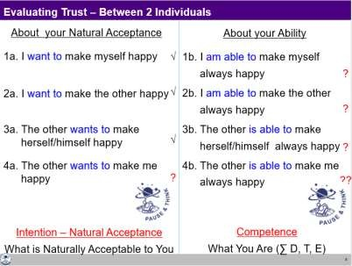

#### Distinguishing between Intention and Competence

Now if you try to analyse your own responses, many things will get clarified. You’ll find that while evaluating yourself, you evaluate on the basis of your intention (natural acceptance). You think that you are a good person as your intentions are good. On the other hand, when you evaluate the other, you evaluate him on the basis of his/her competence. You find that s(he) is

not able to make you happy all the time. Many times, or most of the time he ends up making you unhappy. Therefore, you think that the other wants to make you unhappy. You have a doubt on other’s intention.

On the basis of lack of competence, we conclude about the lack of intention of the other. When we doubt their intention, instead of accepting the other as a relative, we have a feeling of opposition. This is the common mistake that we make in relationship today.

Now that we have clarity about intention and competence, explore this question:

If you have unconditional, continuous trust on intention, on the natural acceptance of the other and if the other is lacking competence, what will you do?

1. Try to improve upon his competence
2. Get irritated
3. Get angry
4. Have a feeling of opposition

The answer is obviously (a). It is a response which indicates trust on intention. All other answers are reactions based on doubt on intention.

Now with these indicators, find out how many people are there in your life on whom you have trust on intention (natural acceptance) which is unconditional and continuous.

Generally, we don’t see intention and competence separately. Since competence is generally lacking, the feeling of unconditional acceptance is almost completely missing; rather there is a feeling of opposition. With that, we reinforce wrong assumptions like:

* Strangers can’t be trusted (?)
* Trust is developed over a long-time (?)
* Never trust anyone (?)

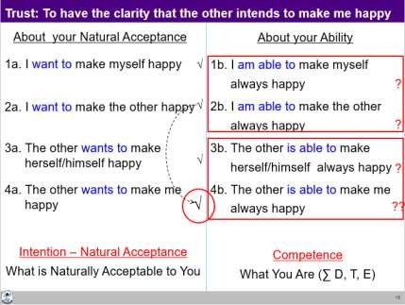

Thus, if we are able to see intention and competence distinctly, we will be able to place a tick mark in 4a. We will be assured of the intention of the other human being. And with that, we will make a programme of interaction with right evaluation of our competence and their competence (so, this is not ‘blind’ trust).

With the feeling of trust, one is able to see it clearly that the intention is same for all, to be happy and make other happy. The only difference lies in the level of competence.

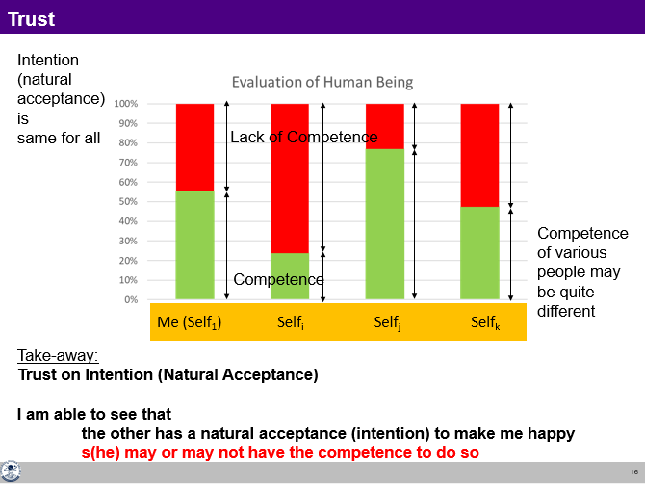

#### Key Takeaways

Trust is to be assured that the other has a natural acceptance (intention) to make me happy and prosperous. Trust on intention is the foundation of relationship. It is the beginning of mutual development. A common mistake is to evaluate oneself on the basis of one’s intention (and conclude that I am good) and the other on the basis of their lack of competence (thus doubt their intention and conclude that the other is bad).

# Respect– As the Right Evaluation

Out of the nine feelings in relationship, we tried to understand the feeling of Trust. With trust on intention, the relationship starts. We will now explore the feeling of respect. Let us see, when do we feel respected? How do I respect others?

#### Feeling of Respect

###### Respect is right evaluation.

When we are rightly evaluated, we feel respected. When we are not rightly evaluated, we feel disrespected.

Disrespect can take place in three ways:

*Over evaluation – evaluating for more than what it is Under evaluation – evaluating for less than what it is Otherwise evaluation – evaluating for other than what it is*

If we look at our day-to-day behavior, we generally tend to do one of these three – over evaluation, under evaluation or otherwise evaluation. If any of these three takes place, the other person feels uncomfortable, disrespected.

#### Minimum Content of Respect – The Other is Similar to Me

When we evaluate the human being on the basis of Self, we are able to see that:

1. **Our purpose is the same** – As I have a natural acceptance to live with continuous happiness and prosperity, it is same with the other. So, on the basis of our natural acceptance, we have the same purpose.
2. **Our programme is same** – As my programme to achieve continuous happiness and prosperity is to understand the harmony and live in harmony at all levels of my being (from human being to the entire existence), it is same with the other. In that sense, our programme to fulfil our purpose is also same.
3. **Our potential is same** – As I am endowed with natural acceptance and the activities of desire, thought and expectation are going on continuously in me, it is the same with the other. So, our potential is also same.

Thus, we can see that **the other (Self) is similar to me**. This is the minimum content of respect for a human being.

#### Disrespect Arising out of Differentiation leading to Discrimination

In general, what we are doing in the name of respect today is differentiating and discriminating.

First set of differentiation is on the basis of body– on the basis of age, gender, race and physical strength. This is based on the gross misunderstanding that human being = Body. The truth is that human being = co-existence of the Self and the Body.

The second set of differentiation is made on the basis of physical facility – on the basis of wealth and post. The gross misunderstanding here is that physical facility = happiness. The truth is that happiness is to be in a state of harmony.

The third basis of differentiation is on the basis of beliefs – on the basis of different isms (thought systems like socialism, capitalism, etc.), different sects, and different sets of information prevalent in

the society. This is founded on the misunderstanding that if the pre-conditioning of the other matches with mine, then the other is respectable, otherwise not. The truth is that pre-conditioning and right understanding are two different things.

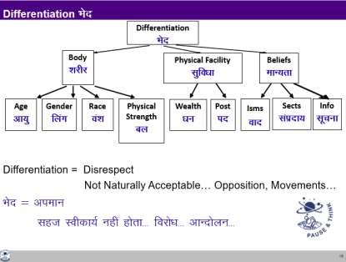

All this differentiation ultimately leads to discrimination, which is disrespect because it is not naturally acceptable.

#### Complete Content of Respect – We are Complementary to Each Other

At the level of the Self, only the competence could be different. Competence means how much of the potential of the Self has been realized. One Self may have realized more of its potential, while another may have realized less of its potential.

This difference in competence is to be complementary to each other (not to discriminate and exploit each other).

The complete content of respect is to be able to see that ‘**the other is similar to me and we are complementary**’.

Defining one’s complementarity:

* If the other has more understanding, is more responsible than me, I’m committed to understand from the other
* If I have more understanding than the other, I’m more responsible than the other. I live with responsibility with the other, unconditionally, unperturbed by the behaviour of the other. I am committed to facilitate the understanding in the other, once the other is assured in relationship and not before that

###### The complete content of respect is

* **The other is similar to me in terms of purpose, programme and potential and**

###### We are complementary to each other in terms of competence

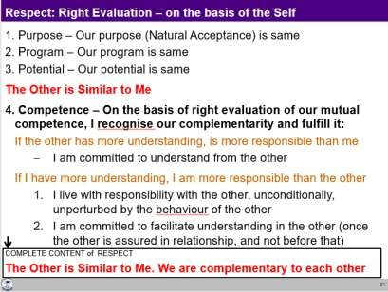

Thus, respect is right evaluation (of intention and competence on the basis of Self). We are similar at the level of purpose, programme and potential and we are complementary at the level of competence.

Disrespect arises out of over-evaluation, under-evaluation or otherwise-evaluation; and also, out of differentiation leading to discrimination on the basis of body, physical facility or beliefs. Small incidents of disrespect can have long-lasting consequences – from not speaking to each other, to opposition, break in relationship, divorce, fights and even war.

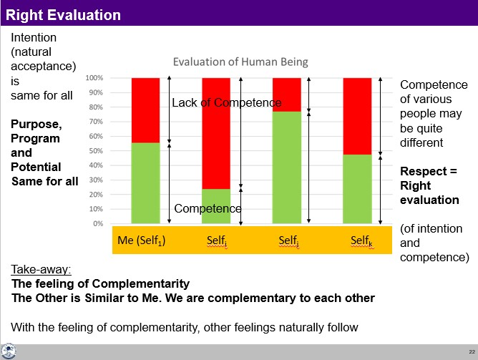

With the complete understanding of respect, we can see for every individual on the earth that we all are the same in terms of intention, program and potential. The only difference may lie in the level of competence. I may be having higher level of competence in relation to one, but may be having lower level of competence in relation to another. With this evaluation, one can work out the program to be complimentary to the other.

All the specific characteristics at the level of Body, physical facility, belief etc. can be used to express that complementarity.

e.g. a person with greater physical strength do the heavy work

e.g. a person at a higher post can work for the development of more people and so on

#### Key Takeaways

Respect is right evaluation at the level of the Self. The complete content of respect is to see that the other is similar to me in terms of purpose, programme and potential; and we are complementary to each other in terms of competence.

Over evaluation, under/otherwise evaluation and discrimination are disrespect.

**Other Naturally Acceptable Feelings in Relationship**

In the previous three lectures, we explored the feelings of trust and respect. Now, we will discuss other feelings, and understand our participation in the family.

1. Affection

###### Affection is the feeling of being related to the other.

Affection is the feeling of acceptance for the other as one’s relative. Lack of affection is seen in the form of opposition, jealousy, etc. The feelings of trust and respect are essential to have the feeling of affection. When we have the feelings of trust, we feel related to the other; otherwise we may feel opposed to the other.

1. Care

###### Care is the feeling of responsibility and commitment for nurturing and protection of the Body of my relative.

With the feeling of affection, one naturally takes the responsibility for development of the relative – both at the level of Self as well as at the level of Body. Being responsible to the Body of one’s relative is Care.

1. Guidance

###### Guidance is the feeling of responsibility and commitment for development of Self by ensuring the right understanding and right feeling in the Self of my relative.

Being responsible to the Self of my relative is Guidance.

Generally, our focus is mostly on care because we have come to assume that human being is Body. We are not even aware of the Self. Therefore, we are not aware that we have to take care of the Self as well.

1. Reverence

###### Reverence is the feeling of acceptance for excellence.

Excellence is to be in a state of continuous happiness with the completeness of understanding of harmony and living in harmony at all levels. Once we achieve excellence, it continues. Excellence is something definite, something absolute.

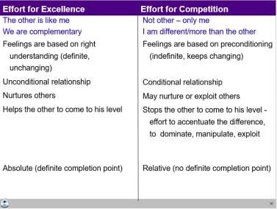

There is a basic difference between working for excellence and competition. If you have achieved excellence, you would naturally make effort for helping others to achieve excellence. On the other hand, in competition, we not only do not help rather we hinder the other to reach to our level.

1. Glory

###### Glory is the feeling of acceptance for those who have made effort for excellence.

For all those people whom we call great people, when we accept the effort made for excellence by them, to whatever extent they are able to achieve it, we naturally have a feeling of glory for them.

1. Gratitude

###### Gratitude is the feeling of acceptance for those who have made the effort for my excellence.

In our life, there may be so many people who have been of help to us in the process of understanding harmony and living in harmony. So, we have this feeling of gratitude for them. Gratitude is a significant feeling in the development of relationship.

1. Love

Love is the feeling of being related to everyone, to all. It starts from affection, which we have already explored. If this feeling expands to many and ultimately to all, it is the feeling of love. So, we begin with the feeling of affection, and complete it with the feeling of love. That is why, Love is called complete value.

###### Love is the feeling of being related to all.

Love is expressed in the form of compassion. The feeling of love is for all and it is expressed to whosoever comes in contact.

Distinguishing Between Love and Infatuation

The feeling of love is not something which is based on sensation. If there is a feeling on the basis of sensation, this is the case of infatuation where the sensual pleasure becomes the major goal. Infatuation is conditional – it may last only as long as you are able to get the sensation or you have hope of getting happiness through sensation. It is very temporary; it does not last for long. Once the effect wears off, then the long-term issues of feelings become prominent.

Right Feeling – within Myself or from the Other?

With this background, we can ask ourselves which can have continuity:

* Right feeling in myself or
* Getting right feeling from the other

The answer is quite obvious that there can be continuity of right feeling, if it is from within and based on right understanding. But generally, we do keep making effort for getting right feeling from the other in continuity.

#### Role of Physical Facility in Fulfilment of Relationship

You can now see that physical facility has a limited role to play in the fulfilment of the feeling in human- human relationship. To fulfil the feeling of care, physical facility is certainly required. For other than the feeling of care, physical facility only has a symbolic role to play.

#### Response and Reaction in Behaviour

An important implication of understanding relationship, particularly trust on intention, is the clarity about problems in living in reaction and the possibility of living with response. With response, your conduct is definite while with reaction, the conduct is indefinite.

#### My Participation (Value) in Family

My participation (value) vis-à-vis my family is to ensure harmony in the family, ensure mutual happiness, ensure justice in the family by way of:

* Ensuring right feelings (trust, respect, affection, care, guidance, reverence, glory, gratitude and love) in myself – this leads to my happiness.

So far, we elaborated on harmony in the individual, family and society. Now, we move to the next level,

i.e. nature. Human order is a part of nature; hence, it is essential to understand the nature and the participation of human being in nature for a mutually fulfilling and sustainable way of living. After discussing nature, we will move on to understand the existence as a whole which is in the form of units (nature) submerged in space.

However, when we refer to our natural acceptance, we want to fulfil all the four orders. Ask yourself this question, “what is naturally acceptable to you – to enrich these four orders or to exploit them”? The

1. Units are Self-organised in Space

Being in co-existence with space, every unit is self-organised. It is in a definite order. By being in a definite order, it exhibits a definite conduct – that is how one can identify or recognise and study that unit.

1. Units Recognise their Relationship and Fulfil it with Every Other Unit in Space

Being in co-existence with space, every unit recognises its relationship with every other unit in space and fulfils that relationship.

#### Existence as Co-existence – Units Submerged in Space

Existence is co-existence. It is in the form of units submerged in space. In the light of above discussion on existence as co-existence, we can now visualise the overall picture of the whole existence.

#### Key Takeaways

Existence is co-existence, which is in the form of units submerged in space. Units are energised, they are self-organised and they recognise their relationship with other units and participate with them in a mutually fulfilling manner (except for human beings without right understanding).

# The Holistic Perception of Harmony in Existence

In the light of this discussion, we can now visualise the overall picture of the whole existence.

#### The Holistic Perception of Harmony in Existence

At the base of the whole existence is co-existence, which unfolds in terms of units submerged in space.

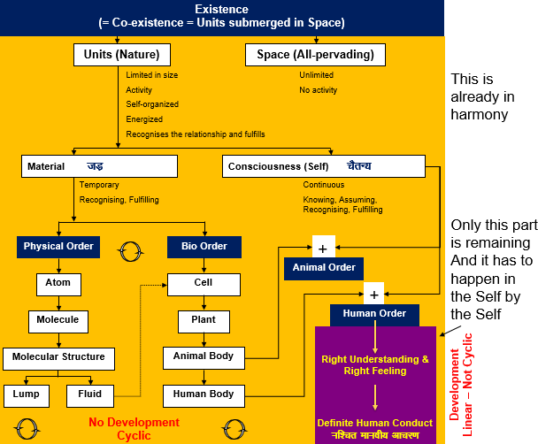

Units are limited in size; they are activity and are active. Space is unlimited, all-pervading and is no activity. Being submerged in space, units are energised, self-organised and recognise their relationship with every other unit in space and fulfil it.

Units are of two types – material units and consciousness units. Material units are temporary in time, while consciousness units (Self) are continuous. Material units recognise and fulfil their relationship with other units– their conduct is definite. Consciousness units recognise and fulfil their relationship on the basis of assuming without knowing or assuming based on knowing – the conduct of the human being is definite if it is operating on the basis of assuming based on knowing; and it is indefinite if it is operating on the basis of assuming without knowing.

All material units are composed of other (simpler) material units. The smallest or fundamental stable material unit is the atom. An atom may combine with another atom to form a molecule. These molecules further combine to form molecular structure. Molecular structures can exist either as lumps, or fluids. Fluids provide nurturing of cells and such cells combine to form plants, the animal body and the human body.

Coming to the domain of consciousness, there is just one type of unit which we have referred to as the Self. We can classify all the units in existence into four orders. Material units can be classified into two orders – physical order and bio order. The animal order is the co-existence of consciousness (Self) and the animal body (material). The human order is also the co-existence of consciousness (Self) and the human body (material).

#### Development in the Existential Sense

Now, we can see that everything is in co-existence. Everything that exists is basically the expression of this ever-present co-existence. It is expressing itself in the form of harmony and relationship. This unfolding is something which is happening and has to be completed through human being.

Whatever we do with the material world is cyclic. It will keep changing; keep going back to initial state, no matter what we do. In that sense, there is no development here. Only in the human order, there is a potential for development or transformation in the Self which is not cyclic. Development or permanent change is possible only in the domain of consciousness. It is in terms of

* 1. developing right understanding (understanding co-existence) and right feeling (feeling of co- existence) in the Self. It means awakening to the activities of contemplation (of relationship, participation in the larger order), understanding (of self-organisation, harmony) and realisation (of co-existence), as discussed earlier, and

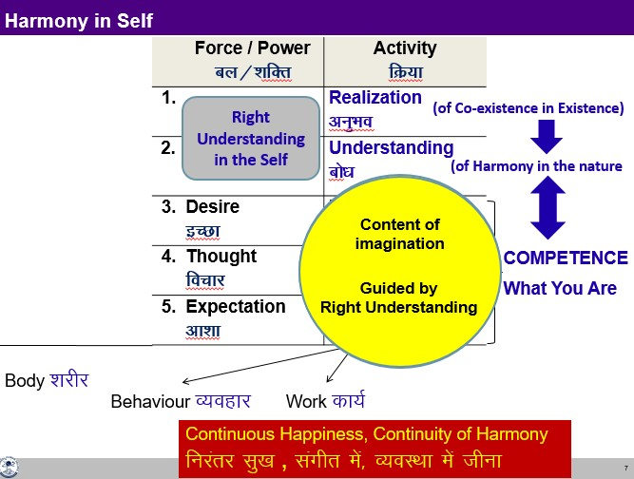

* 1. living on the basis of right understanding and right feeling- part one is updating all our desires, thoughts and expectations in line with right understanding and right feeling; part two is the expression in the form of behaviour, work and participation in the larger order.

This development, this transformation in human being is facilitated by education-sanskar. There is every provision in existence for this development.

# Sum Up

Now, we can sum up all that has been discussed in the workshop. We started by explaining the meaning of value. It was put as shown in the figure:

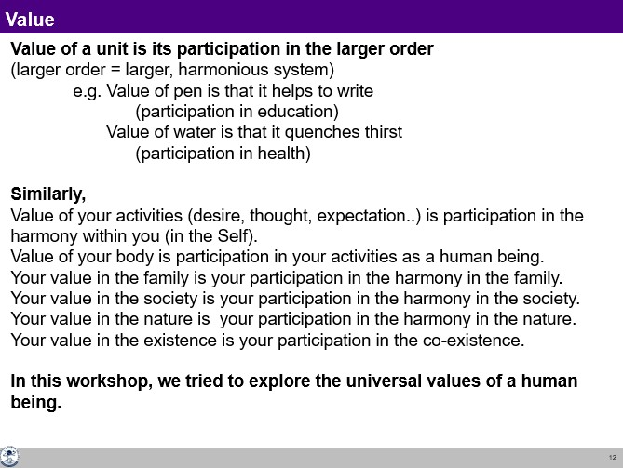

Then we went on to discuss the value at all the levels which is explained below.

#### Expression of Co-existence at Different Levels

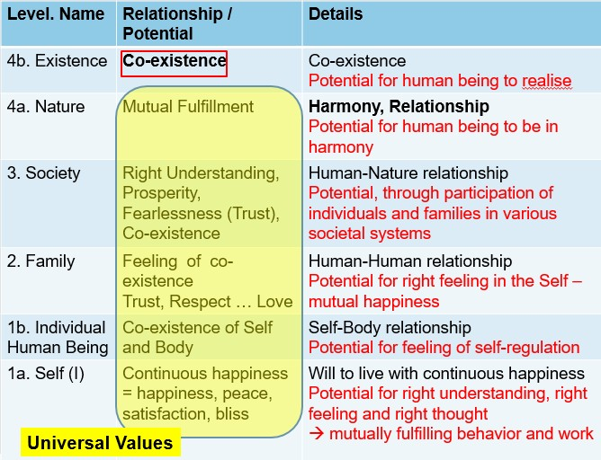

With this background, we can see that all that we discussed about harmony at the level of individual, family, society and nature are basically the systematic reflection (the expressions) of existence as co- existence. The same is shown in figure below. The whole discussion so far can be summed up in a simple chart given below. It can be expressed in one word – ‘**Co-existence**’.

#### Natural Outcome of the Understanding

The completion point for human being (materialising universal human order) is also the completion point of the universal order in existence. In that sense, the universal human order and universal order are synonymous. This is also the total expression of existence. It is the completion point of unfolding of the existence as co-existence.

**Thus, My Participation (Value) in Existence is to Realize the Co-existence and Live in Co- existence.**

#### Key Takeaways

Existence is co-existence, and the role of human being is to realise co-existence in the Self and live in co-existence in nature/existence, extending up to universal human order. In this way, the unfolding of the co-existence will be completed through human being – resulting into universal order.

# Program of Action

With the discussion so far, now we can work out the program of action at the individual level and at the level of society.

At the level of individual, what is expected is to understand harmony and live in harmony. This is something that has been initiated in the workshop.

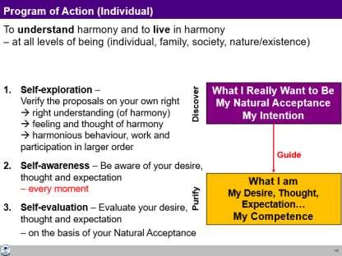

In the process of understanding, three things are required as mentioned above:

* + 1. Self-exploration: Verifying the proposals on our own right and living accordingly
    2. Self-awareness: Being aware of one’s desires, thoughts and expectations every moment
    3. Self-evaluation- Evaluating one’s competence vis-à-vis the natural acceptance every moment.

These three things will help one transform from the present level of competence to the level of completeness of right understanding and right living in continuity. The time taken for this may vary from person to person, but the process is definite.

At the level of society, what is expected is shown in the figure below.

